Molecules in Two Dimensions
Adapted from Living By Chemistry’s “Molecules in Two Dimensions”

Purpose
To compare the structures of molecules.

Part 1: Smell Predictions
Write your predictions in the table.

Chemical name | Molecular formula | Smell
ethyl pentanoate | C₇H₁₄O₂
butyric acid | C₄H₈O₂
ethyl acetate | C₄H₈O₂

What could account for two molecules with the same molecular formula having different smells?

Part 2: Examine the Structures
Below are structural formulas of each of the three substances. They show how the atoms in each molecule are connected.

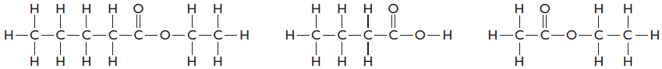
ethyl pentanoate butyric acid ethyl acetate

Questions
1. List three similarities between butyric acid and ethyl acetate.

2. List two differences between molecules butyric acid and ethyl acetate.

3. List three similarities between the two sweet-smelling molecules.

4. What do you suppose the lines in these drawings represent?

5. From the evidence you have seen so far, how would you explain the differences in smell between butyric acid and ethyl acetate?

6. Five more structural formulas are shown here.
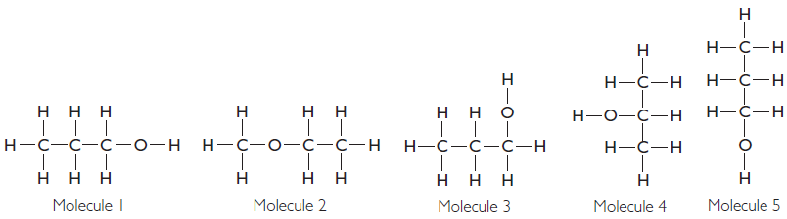

Write their molecular formulas:

7. Molecules 1, 3, and 5 smell exactly the same. They represent the same molecule. Explain why.

8. Molecules 1, 2, and 4 have different smells. Explain why.

Part 3: Examining Other Structures
9. Contrast the four smell pages that you have. What are some structural features(not formula features) that make the smell molecules on each page different from smell molecules on another page?
Minty Fishy Sweet Putrid

10. Making Sense: What evidence is there that the structure of a molecule is related to how it smells?

11. If You Finish Early: Draw molecule 4 so that it looks different on paper but still represents the same molecule.

Minty

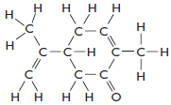
C₁₀H₁₄O

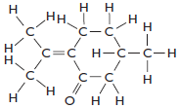
C₁₀H₁₆O

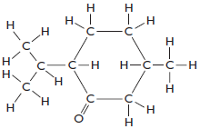
C₁₀H₁₈O

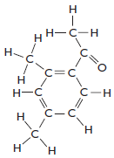
C₁₀H₁₂O

Fishy

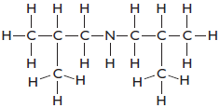
C₈H₁₉N

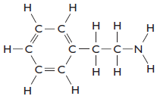
C₈H₁₁N

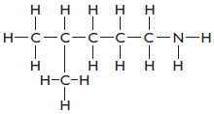
C₆H₁₅N
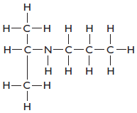
C₆H₁₅N

Putrid

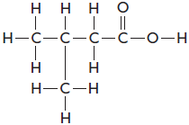
C₅H₁₀O₂

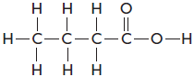
C₄H₈O₂

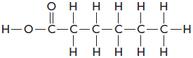
C₆H₁₂O₂

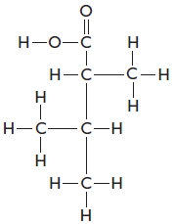
C₆H₁₂O₂

Sweet

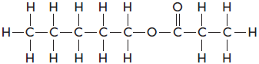
C₈H₁₆O₂

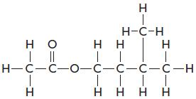
C₇H₁₄O₂

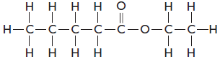
C₇H₁₄O₂

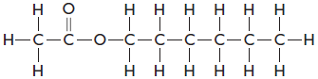
C₈H₁₆O₂

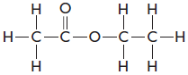
C₄H₈O₂

Molecules in Two Dimensions
Adapted from Living By Chemistry’s “Molecules in Two Dimensions”

Purpose
To compare the structures of molecules.

Part 1: Test Your Predictions
Write your predictions in the table.

Chemical name | Molecular formula | Smell
ethyl pentanoate | C₇H₁₄O₂
butyric acid | C₄H₈O₂
ethyl acetate | C₄H₈O₂

What could account for two molecules with the same molecular formula having different smells?

Part 2: Examine the Structures
Below are structural formulas of each of the three substances. They show how the atoms in each molecule are connected.

ethyl pentanoate butyric acid ethyl acetate

Questions
1. List three similarities between molecules G and H.

2. List two differences between molecules G and H.

3. List three similarities between the two sweet-smelling molecules.

4. What do you suppose the lines in these drawings represent?

5. From the evidence you have seen so far, how would you explain the differences in smell between molecules G and H?

6. Five more structural formulas are shown here.

Write their molecular formulas:

7. Molecules 1, 3, and 5 smell exactly the same. They represent the same molecule.
Explain why.

8. Molecules 1, 2, and 4 have different smells. Explain why.

9. Making Sense: What evidence is there that the structure of a molecule is related to how it smells?

10. If You Finish Early: Draw molecule 4 so that it looks different on paper but still represents the same molecule.

Molecules in Two Dimensions
Adapted from Living By Chemistry’s “Molecules in Two Dimensions”

Purpose: In this lesson you are introduced to the structural formulas of the molecules you have smelled plus some new molecules. You will look for patterns in the ways the atoms are connected.

Instructions: Sort the structural formula cards any way you wish, as long as it is consistent and makes some sense. Then, complete the following:

1. Describe how your group sorted the structural formula cards.

2. Look for patterns in your groups. Write down as many patterns as you can find within the groups.

3. Look for differences between groupings. Write down as many differences between the groupings as you can find.

Making Sense:
What structural features seem to be the best predictors of the smell of a molecule?

