Modeling the Sun

Model: In science, models are used to represent a system (or parts of a system) under study, to aid in the development of questions and explanations, to generate data that can be used to make predictions, and to communicate ideas to others.

Create a model of the Sun. Be sure to include the following elements:
What elements are inside the Sun?*
What happens inside the Sun to give off energy?*
What is the Sun’s life span?
How is Earth affected by the Sun?

Sun

Earth
*Note: not to scale

Scoring Elements | Beginning | Approaching Expectations | Meets Expectations | Advanced
Explains Phenomena: Does my model explain the energy given off by the Sun? | Model does not explain the energy given off by the Sun. | Model includes some of the relevant parts of the model to explain what causes the energy given off by the Sun. Model might include text and diagrams. | Model connects all relevant components and relationships (observable and unobservable) of the model to explain what causes the energy given off by the Sun. Model includes text and diagram(s) to describe the model pieces and processes. | Model includes the relevant parts of the model to explain what causes the energy given off by the Sun (as in Level 3) – as well as additional components and relationships that fit the scientific model.
Fits with Evidence: Does my model fit with the evidence collected? | Evidence is not correctly related to the model. | Model correctly incorporates some of the evidence collected through investigations. | Model refers to a sufficient amount of relevant evidence collected through the investigations to be compelling. | Model fits with all of the evidence collected and additional evidence that could be collected is described.
Clarity of Communication: Would someone else be able to understand my model? | Model is not clearly described. | Model is somewhat clearly described. | Model is clearly explained in a way that allows others to understand how and why the phenomenon happens. Diagram and text include agreed-upon AND personally compelling conventions for representation. | Model is clearly described and additional communication or educational pieces are included for the audience.

Scoring Elements | Beginning | Approaching Expectations | Meets Expectations | Advanced
Modification of my Model: Did I modify my model based on new data and explain those modifications? | I vaguely explained how I changed my model but did not connect my changes to evidence. Or, I did not revise my model. | I explain how I changed my model to better explain what caused the phenomenon, but only loosely connected my changes to evidence. | I explain how I changed my model to better explain what caused the phenomenon as I gathered new evidence and/or developed new ideas about components or relationships of the model. | I explain how I changed/added to my model to better explain what caused the phenomenon and clearly connected to newly gathered evidence and/or ideas about components or relationships of the model.
Evaluating Limitations of my Model: Do I describe the limitations of my model? | No limitations defined or only cosmetic changes suggested. | Some explanation of limitations. Little connection to the phenomena the model represents. | I explain what simplifications I have made in my model compared to the phenomena from the natural or built world. | I explain the limitations of my model and discuss how this limits its use to explain other related phenomena and suggest improvements and unanswered questions.
Use my Model to Predict a Phenomena: Can I use my model to make a prediction about how the relative amounts of hydrogen and helium will change over time? | I do not use my model to predict how the relative amounts of hydrogen and helium will change over time. | I attempt to use my model to predict how the relative amounts of hydrogen and helium will change over time, but I am missing some connections between my model and the change in amounts of hydrogen and helium. | Model is used to predict and explain how a different relative amounts of hydrogen and helium will change over time. | I identify and predict/explain what will happen as the composition of the Sun continues to change over billions of years.

Additional Evidence

Our Sun:

Surface Temperature: 5,800 K Mass: 2 × 10³⁰ kg Radius: 6.95 × 10⁵ km Luminosity: 3.85 × 10²⁶ W

Spectrum found for the Sun (the majority of elements):

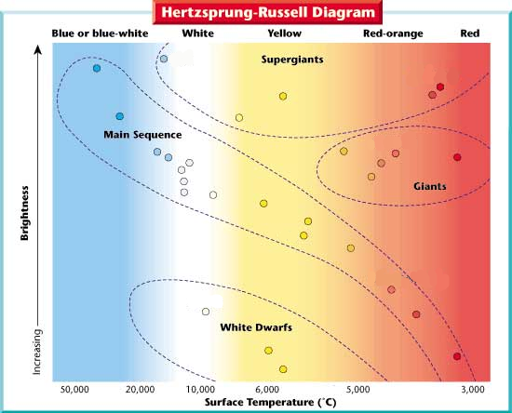

Dwarf Stars
Star Type | Color | Surface Temperature (K) | Average Mass ( × 10³⁰ kg) | Average Radius  (× 10⁵ km) | Average Luminosity (× 10²⁶ W) | Lifespan  (billion years)
Yellow Dwarf | White to  Yellowish White | 5,200 –7,500 | 0.16 – 2.8 | 6.72 – 9.8 | 2.4 – 20 | 4 – 17
Orange Dwarf | Yellow Orange | 3,700 – 5,200 | 0.9 – 0.16 | 4.9 – 6.72 | 0.32 – 2.4 | 17-73
Red Dwarf | Orange Red | Under 3,700 | 0.16 – 0.9 | 0.84 – 4.9 | 0.0004 – 0.32 | 73 - 5500

Giant and Supergiant Stars
Star Type | Color | Surface Temperature (K) | Mass  ( × 10³⁰ kg) | Radius  (× 10⁵ km) | Luminosity (W) | Lifespan  (billion years)
Blue Giant | Blue  to Blue White | 7,500 – Over 30,000 | 2.8 – 530 | 9.8 – 1750 | 20 – 36,000,000 | 0.003 – 4
Red Giant | Yellow to Orange Red | 3,200 – 5,200 K | 0.6 – 20 | 140 – 700 | 400 – 4000 | 0.1 – 2
Red Supergiant | Yellow to Orange Red | 3,200 – 5,200 K | 20 – 80 | 700 – 11,550 | 4,000 – 3,200,000 | 0.003 – 0.1

(adapted from http://www.enchantedlearning.com/subjects/astronomy/stars/startypes.shtml, https://sciencetrends.com/kind-star-sun/, https://owlcation.com/stem/Different-Types-of-Stars-in-the-Universe, and http://www.phschool.com/atschool/science_activity_library/types_of_stars/diagram.html)

