Ionic Bonding Modeling

For each pair of elements below draw an atomic diagram showing electrons in different energy levels. Draw arrows to show where the outer electrons will go during a chemical reaction, then draw the resulting compound. Finally, fill in the table below each reaction. Refer to the sample shown.

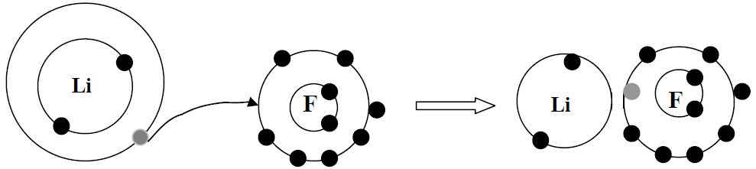
Li + F LiF
Atoms Valence Electrons Electron transfer from/to each atom Ions formed in the product
Li
F

Reactions | Atoms | Valence Electrons | Electron transfer from/to each atom | Ions formed in the product
1) Li + Cl LiCl

2) Be + O BeO
3) Be + F BeF₂
4) Mg + S MgS

Reactions | Atoms | Valence Electrons | Electron transfer from/to each atom | Ions formed in the product
5) Al + F AlF₃

6) Na + O Na₂O
7) Li + N
8) Mg + F
9) Na + F
10) Al + O
11) Li O
12) Mg + O

