**The ICE Table**

*A worked example:*

Initially 1.50 moles of N2(g) and 3.50 moles of H2(g) were added to a 1 L container at 700 °C. As

a result of the reaction

N2(g) + 3H2(g) ⇌ 2NH3

the equilibrium concentration of NH3(g) became 0.540 M. What is the value of the equilibrium constant for this reaction at the given temperature of 700 °C.

|  |  |  |  |  |
| --- | --- | --- | --- | --- |
|  | N2(g) + | 3H2(g) | ⇌ | 2NH3 |
| **I.** Write the **I**nitial concentrations  of reactants and products: | 1.50 mol L‐1 | 3.50 mol L‐1 |  | 0 mol L‐1 |
| **C**. Write the **C**hange in  concentration due to reaction  using the given reaction  stoichiometric coefficients: | −x | −3x |  | +2x |
| **E**. Write the reactant and product concentrations at **E**quilibrium. | 1.50 mol L‐1 – x | 3.50 mol L‐1 − 3x |  | 0.540 M  and/or  0 + 2x mol L‐1 |

We are now set to solve for the equilibrium constant *KC* using the *equilibrium equation*:

*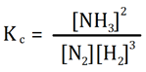eqn. 1*

where the reactant and product concentrations should be expressed at equilibrium. The problem tells us that the equilibrium concentration of NH3 is 0.540 M, thus we can solve for the unknown ‘x’

[NH3]eq = 0 + 2x = 0.540 M

x = 0.270 M

we can now solve for *K*C

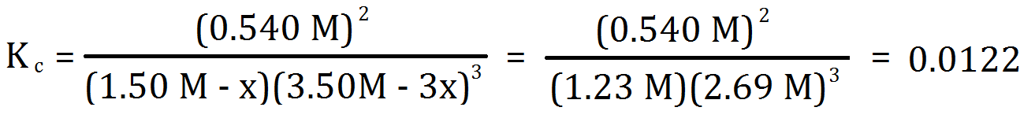

***Key Questions***

(i) In the above reaction we can monitor the change in concentration of reactants over time

(just as we discussed when dealing with kinetics) and we can plot the data as follows:



Using the worked example from Model 1 label each data plot as either [H2], [N2] or [NH3].

Why does one data plot show an initial positive slope whereas the other two data plots show initial negative slopes?

Why does the uppermost plot have a steeper initial slope than the middle plot.

At which time a, b, c or d is an equilibrium state reached?

(ii) The equilibrium constant for this reaction was calculated as shown below. What is *K*c for the reverse reaction?

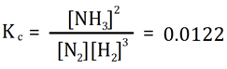

***EXERCISES***

1. Initially, 1.0 mol of NO(g) and 1 mol of Cl2(g) were added to a 1 L container. As a result of the reaction

2 NO (g) + Cl2 (g) ⇌ 2 NOCl (g)

the equilibrium concentration of NOCl(g) became 0.96 M. Using the ICE table methodology determine the value of the equilibrium constant *K*C for this reaction.

Solve for *K*C :

I. Write the **I**nitial concentrations

of reactants and products:

C. Write the **C**hange in

concentration due to reaction

using the given reaction

stoichiometric coefficients:

E. Write the reactant and product

concentrations at **E**quilibrium.

*Answer: K*C = 1.11 x 103

2. 3.00 moles of NO(g) are introduced into a 1.00-Liter evacuated flask. When the system comes to equilibrium, 1.00 mole of N2O(g) has formed. Determine the equilibrium concentrations of each substance. Calculate the Kc for the reaction based on these data.

2N2O(g) + O2(g) ⇌ 4NO(g)

*Answer:* Kc = 2.0

3. 1.00 mol of ethanol (C2H5OH ) and 1.00 mol of acetic acid (CH3COOH) are dissolved in water and kept at 100°C. The volume of the solution is 250mL. At equilibrium, 0.25 mol of acetic acid has been consumed in producing ethyl acetate (CH3COOCH2CH3). Calculate Keq at 100°C for the reaction. Are products or reactants favored?

C2H5OH (aq) + CH3COOH (aq) ↔ CH3COOCH2CH3 (aq) + H2O(l)

**Answer:** Keq = 0.11, reactants are favored

4. 0.0175 mol of H2 and I2 are placed in a 1.00L flask at 1000K. When equilibrium has been reached, 0.0276mol of HI has been formed. Calculate Keq at 1000K for this reaction. Are products or reactants favored?

H2 (g) + I2 (g) ↔ 2HI (g)

**Answer:**  Keq = 55.6, products are favored

5. 1.00 mol of SO2 and 1.00 mol of O2 are placed in a 1.00L flask at 1000K. When equilibrium has been achieved, 0.925 mol of SO3 has formed. Calculate Keq at 1000K for this reaction. Are products or reactants favored?

2SO2 (g) + O2 (g) ↔ 2SO3 (g)

**Answer:** Keq = 283, products are favored

6. 3.00 moles of N2 reacts with 4.00 moles of H2 in the reaction below. How many moles of each substance are present at equilibrium if 1.36 moles of NH3 are formed?

N2(g) + 3H2(g) <--> 2NH3(g) 

**Answer:** Keq = .106, reactants are favored