Enthalpy Changes in Chemical Reactions
(Is Energy Released or Consumed When a Chemical Reaction Occurs?)

Model 1: The Enthalpy Change for a Chemical Reaction.
Table 1. Standard state enthalpies of atom combination, ∆H°_{ac}
Substance | ∆H°_{ac} (kJ/mol) | Substance | ∆H°_{ac} (kJ/mol)
H(g)  N(g)  O(g)  H₂(g)  N₂(g)  O₂(g) | 0  0  0  –435.30  –945.408  –498.340 | NH₃(g)  NO₂(g)  N₂O₄(g) | –1171.76  –937.86  –1932.93

To determine the overall value of ∆H° for a chemical reaction, one can consider the reaction to take place by breaking apart all of the reactant molecules into their constituent atoms, and then reassembling those atoms into the product molecules. Although (in general) this is not the actual process that takes place when chemical reactions occur, thinking about the reaction in this manner is a valid way to determine the value of ∆H° for the reaction.

Figure 1. The enthalpy diagram for a chemical reaction.
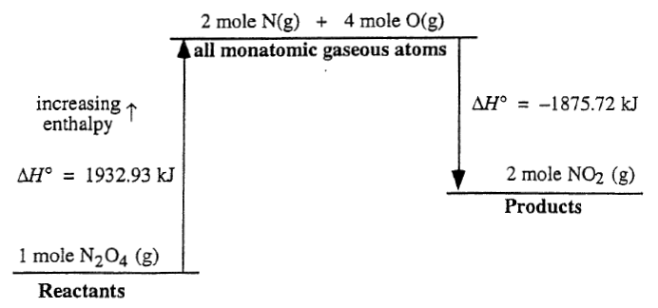

Overall reaction: N₂O₄(g) 2NO₂(g)

Critical Thinking Questions

1. How much energy is required to break one mole of N₂O₄(g), the reactants, into gaseous atoms?

2. Why is the ∆H° associated with the upward arrow (left-side of Model 1) a positive number?

3. How much energy is released when two moles of NO₂ (g), the products, are formed from gaseous atoms?

4. Why is the ∆H° associated with the downward arrow (Model 1) a negative number?

5. For the overall reaction:
a) is energy released or required?

b) is the reaction endothermic or exothermic?

6. Based on the information in Figure 1, what is the ∆H° for the following reaction?

N₂O₄(g) 2NO₂(g)

7. For the reaction:

N₂(g) + 3H₂(g) 2NH₃(g)

a) make a diagram similar to that in Figure 1 using Model 1 on the first page to help you.

b) calculate ∆H° based on your diagram.

8. Using grammatically correct sentences, describe how to calculate the ∆H° for the reaction in CTQ 7 given the ∆H°_{ac} of the three species.

9. For any given chemical reaction, if the sum of the enthalpies of atom combination for all of the reactants is greater than the sum of the enthalpies of atom combination for all of the products, will the value of ∆H° for the reaction be positive or negative? Explain your reasoning.

Heat of Formation, ∆H°_{f}
Substance | ∆H°_{f} (kJ/mol)
MgO(s)  Mg(OH)₂(s)  O₂(g)  H₂O (l)  H₂O (g)  Zn(s)  ZnO(s)  TiCl₄(g)  TiO₂(s)  HCl(g)  CH₃OH(l)  CH₃OH(g)  SO₃(s)  SO₃(l)  SO₃(g) | –601.8  –924.7  0  –285.8  –241.8  0  –348.0  –763.2  –944.7  –92.3  –238.6  –201.2  –490.0  –441.0  –395.7
Exercises

1. Calculate ∆H° for each of the following reactions:

a) MgO(s) + H₂O (l) Mg(OH)₂(s)

b) 2Zn(s) + O₂(g) 2ZnO(s)

c) TiCl₄(g) + 2H₂O(g) TiO₂(s) + 4HCl(g)

Problem
1. As mentioned previously, molecules attract each other. The forces of attraction between molecules are called intermolecular forces. Consider the following transformations:

CH₃OH(l) CH₃OH(g)
H₂O(l) H₂O(g)
SO₃(s) SO₃(l)
SO₃(s) SO₃(g)

Calculate the value of ∆H° for each of these transformations.
2. Based on the results you obtained for these results, in which phase (gas, liquid, solid) are the intermolecular forces the weakest? The strongest? Explain your reasoning.

Model 2: Bond Strength and Enthalpies of Atom Combination.

Recall that for bonds between pairs of atoms, “the stronger the bond, the shorter the bond length.” That is, a C–O double bond is stronger than a C–O single bond, and the double bond is also shorter. For bonds between similar atoms, we also find that “the shorter the bond length, the stronger the bond.”

Critical Thinking Questions

Standard state enthalpies of atom combination, ∆H°_{ac}
Substance | ∆H°_{ac}
HF(g)  HCl(g)  HBr(g)  CH₄(g)  CH₃Cl | –271.1  –92.3  –36.4  –1662.09  –1572.1
10. Based on bond lengths, which do you expect to have the strongest bond, H–F (0.092 nm), H–Cl (0.127 nm), H–Br (0.141 nm)? Which has the weakest bond? Are your predictions consistent with the ∆H°_{ac} data for HF(g), HCl(g), HBr(g)? Explain your reasoning.

11. Based on bond lengths, which do you expect to be the stronger bond, C–H (0.109 nm) or C–Cl (0.177 nm)? Is your prediction consistent with the values of ∆H°_{ac} for CH₄(g) and CH₃Cl(g)? Based on these values, predict ∆H°_{ac} for CH₃F(g) and CH₃Br(g). Explain your reasoning.

