Bond Enthalpy

Bond energy is defined as the amount of energy required to break a bond. These values are positive, indicating that bond breaking is endothermic. Bond energies are reported in kilojoules per mole (kJ/mol). The energy for breaking a hydrogen-hydrogen bond is +436 kJ/mol so when a hydrogen-hydrogen bond is formed the process releases 436 kJ/mol (therefore -436 kJ/mol).

In a chemical reaction several bonds are broken and formed. For example in the reaction below a hydrogen-hydrogen bond is broken and a fluorine-fluorine bond is broken. Two hydrogen-fluorine bonds are formed. The overall energy change for this process is calculated below.

Example
H–H
Bond Energy: 436 kJ/mol

F–F
Bond Energy: 155 kJ/mol

H–F
Bond Energy: 567 kJ/mol
H₂(g) + F₂(g) 2HF

∆H_{rxn} = [energy used for breaking bonds] – [energy formed in making bonds]

[(436 kJ/mol) + (155 kJ/mol)] – [2(567 kJ/mol)]

= - 543 kJ/mol

Average Bond Energies (kJ/mol)
H–H  H–Cl  H–F  N–H  N–O  O–H  O–O  F–F | 436 kJ/mol  431 kJ/mol  567 kJ/mol  391 kJ/mol  201 kJ/mol  463 kJ/mol  146 kJ/mol  155 kJ/mol | C–H  C–C  C–N  C–O  C–F  C–Cl  C–S  Cl–Cl | 413 kJ/mol  348 kJ/mol  293 kJ/mol  358 kJ/mol  485 kJ/mol  328 kJ/mol  259 kJ/mol  242 kJ/mol | C=C  C≡C  C=O  O=O  C≡O  C=N  N=N  N≡N  C≡N | 614 kJ/mol  839 kJ/mol  799 kJ/mol  495 kJ/mol  1072 kJ/mol  615 kJ/mol  418 kJ/mol  941 kJ/mol  891 kJ/mol

Estimate the enthalpy change (∆H_{rxn}) for the following reactions using the bond energies above.

1. 4. 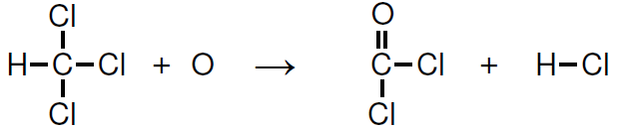

2.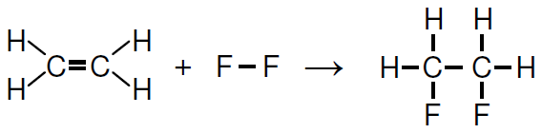 5. 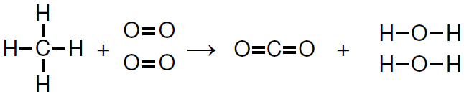

3.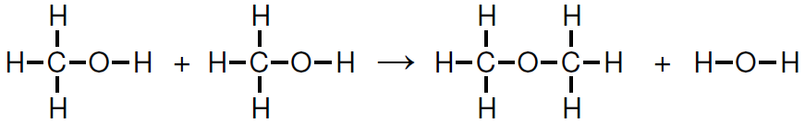
Draw Lewis structures for reactants and products. Estimate the enthalpy change (∆H_{rxn}) for the reactions using bond energies.

6. 2H₂O₂ (g) 2H₂O (g) + O₂ (g) 9. 2C₂H₆ (g) + 7O₂ (g) 4CO₂ (g) + 6H₂O (g)
7. N₂ (g) + 3H₂ (g) 2NH₃ (g) 10. CH₄ (g) + 3Cl₂ (g) CHCl₃ (g) + 3HCl (g)
8. H₂ (g) + C₂H₄ (g) C₂H₆ (g) 11. HCN (g) + 2H₂ (g) CH₃NH₂ (g)

Answers:
-2831 kJ/mol -808 kJ/mol -549 kJ/mol -489 kJ/mol -312 kJ/mol -203 kJ/mol -184 kJ/mol
-138 kJ/mol -124 kJ/mol -97 kJ/mol 0 kJ/mol

