Balancing Chemical Equations Simulation

Pieces of colored paper will be used to represent atoms in chemical equations. Different colors will represent different atoms. Conservation of atoms in a chemical equation will be shown by having the same number and kinds of atoms on each side of the equation. You will use the squares to simulate and balance the reactant (left) side and the product (right) side of the equation. Use the key below to help you determine which color represents each atom.

ELEMENT | COLOR | QUANTITY
H | white | 8
Cl | green | 4
O | red | 14
N | blue | 6
C | black | 6
Na | yellow | 4
Fe | orange | 4

For equations (1) - (5) below, complete the following steps:

a. Balance the equations by using the squares to simulate the left side and the right side of the equation on a separate piece of paper. Use the small pieces of paper with + or as appropriate. Make sure that there are the same number of pieces of each kind and color on each side of the equation.
b. When you have completed an equation, have your instructor check the balanced equation and the square arrangement to verify that everything is correct.

(1) ___ Na + ___ Cl₂ ___ NaCl

(2) ___ Na + ___ H₂O ___ NaOH + ___ H₂

(3) ___ CO + ___ NO ___ CO₂ + ___ N₂

(4) ___ C + ___ Fe₂O₃ ___ CO + ___ Fe

(5) ___ Fe₂O₃ + ___ CO ___ Fe + ___ CO₂

The drawings for equations (6) - (10) below represent unbalanced chemical equations.
For these equations, first use the drawings and the key provided to write the unbalanced equation, and then follow the same procedure for to balance the equation by simulating with squares.
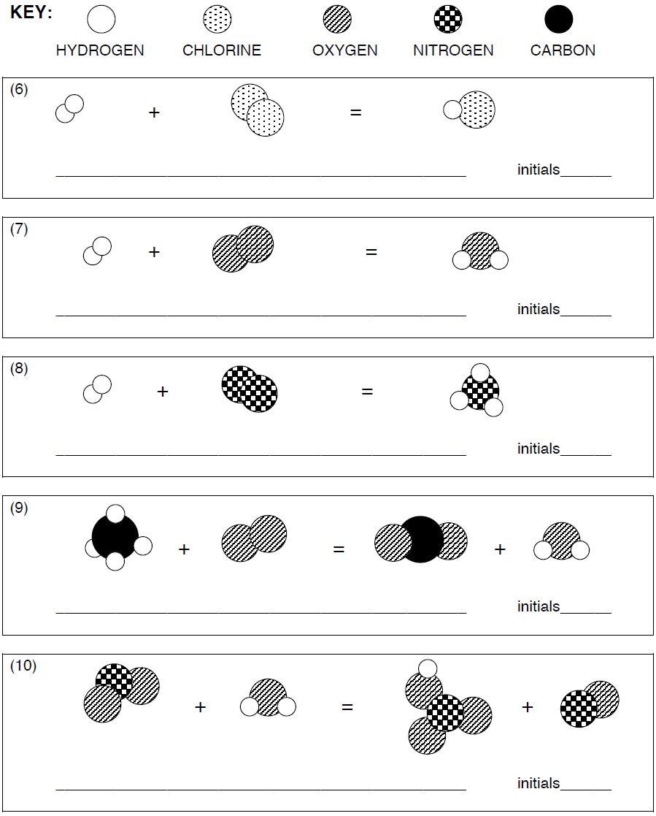

Use the following page to help you balance your equations. Remember, there should be the same number of each element on both sides.

+

+ +

