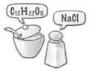
A New Language
Chemical Names and Symbols

Purpose
To learn the language of chemical symbols and chemical names.

Part 1: Observations
Look at each vial and fill in the data in the table.
Vial | Name | Chemical Formula | Description
1
2 | copper (II) nitrate
3
4
5 |  | NaNO₃ (s)
6
7
8
9 | nitric acid
10 |  |  | brown powder
11 |  | NaOH (aq)
12
13
14 |  |  | clear, colorless solution
15 | zinc sulfate
16
17 |  | Cu(NO₃)₂ (aq)

Part 2: Cracking the Code
1. Examine the contents of the vials and their labels. Write down at least six patterns you notice.

2. Note how many of each element would be found in one particle of the following compounds:
a. sugar (C₁₂H₂₂O₁₁) b. salt (NaCl) c. baking soda (NaHCO₃)

3. These symbols represent elements. Identify each element.
a. Cu b. H c. Zn

4. Translate these element names into their symbols.
a. sulfate b. nitrate c. hydroxide

5. Compounds are substances that are made up of more than one element. In your data table, place a C next to the number of each vial that contains a compound.

6. What do you think (s), (l), and (g) stand for?

7. How would you write the chemical formula for ice?

8. What do all the substances labeled (aq) have in common?

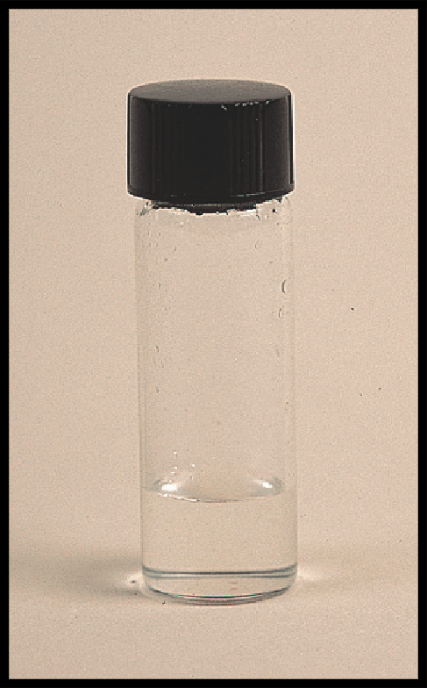  1. sodium nitrate, NaNO₃ (aq) | 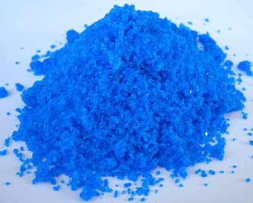  2. copper (II) nitrate,  Cu(NO₃)₂ (s) | 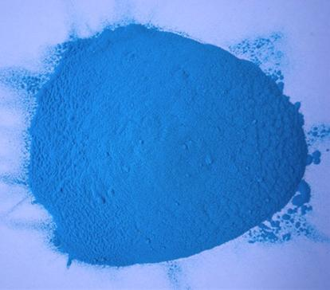  3. copper (II) hydroxide, Cu(OH)₂ (s) | 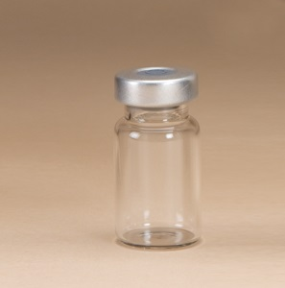  4. hydrogen, H₂ (g) | 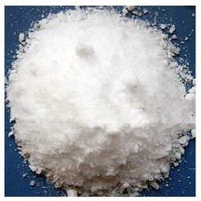  5. sodium nitrate, NaNO₃ (s)
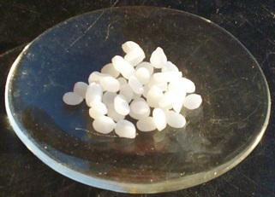  6. sodium hydroxide,  NaOH (s) | 7. sulfuric acid,  H₂SO₄ (aq) | 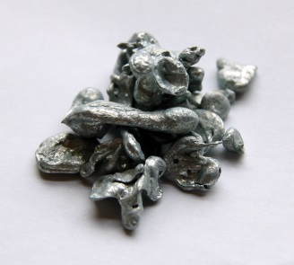  8. zinc, Zn (s) | 9. nitric acid,  HNO₃ (aq) | 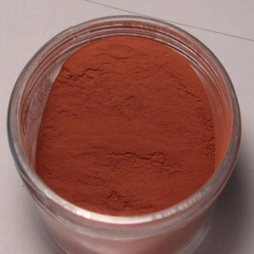10. copper, Cu (s)
11. sodium hydroxide, NaOH (aq) | 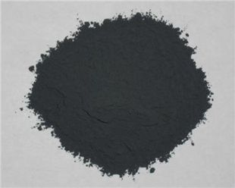  12. copper (II) oxide, CuO (s) | 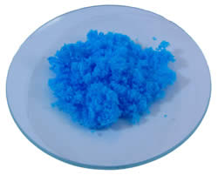  13. copper (II) sulfate, CuSO₄ (s) | 14. water, H₂O (l) | 15. zinc sulfate,  ZnSO₄ (aq)
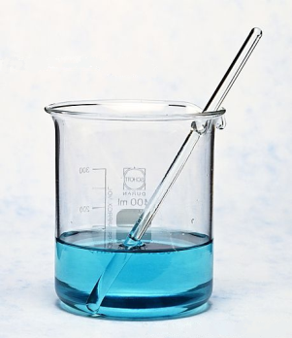  16. copper (II) sulfate, CuSO₄ (aq) | 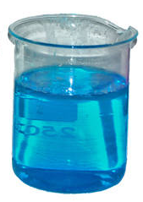  17. copper (II) nitrate, Cu(NO₃)₂ (aq)

