The Pressure’s On!
(Adapted from Living By Chemistry 1st Ed Weather 11 and 12)

Part 1: Glass Bottle (Rigid Container)
The air trapped inside a 240 mL glass bottle has a pressure of 1.0 atm and a temperature of 25.0°C. You put the glass bottle into a freezer. After several hours, the air trapped inside the bottle has a temperature of -35.0 °C and a pressure of 0.80 atm.

Initial Final
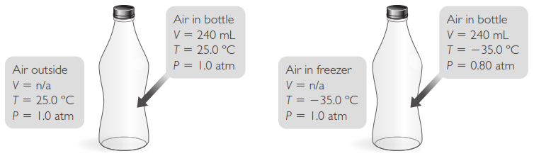
1. When the glass bottle is put into the freezer, how does the air trapped inside the bottle change with regards to volume, temperature, and pressure? How is it the same?

2. The table shows data for the glass bottle in four locations. The atmospheric pressure stays unchanged at 1.0 atm, but the temperature is different at each location.
a. Complete the table.
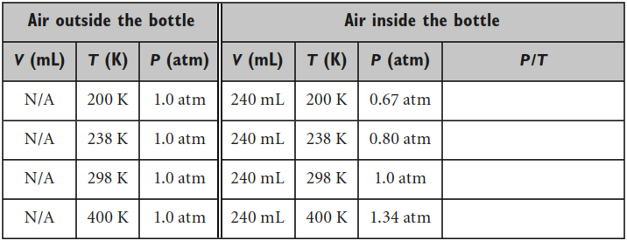

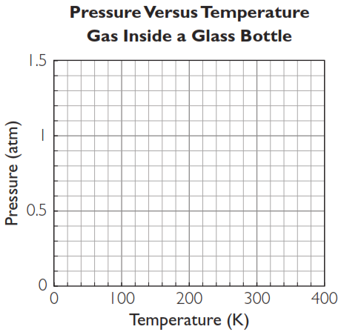
b. Plot pressure versus temperature for the air inside the glass bottle at each location. Draw the best-fit line through the data points to determine the pressure inside the glass bottle if the temperature is 350 K.

3. A sample of chilled air from a freezer is sealed up inside a glass bottle with a volume of 240 mL. This bottle is then allowed to warm to room temperature. What is the air pressure inside the bottle at 25 °C? Show your work.
Initial Final
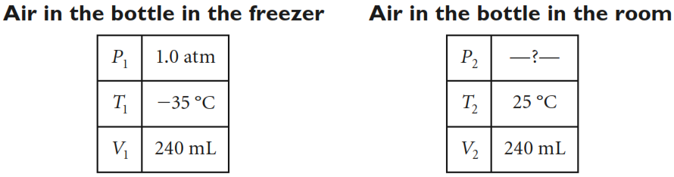

Part 2: Car Air Bag (Flexible Container)
Identical air bags inflate in two different cars. One car is at sea level, and the second car is in the mountains. The temperature, pressure, and volume of the air outside the air bag and of the gas inside the air bag are given in the table.
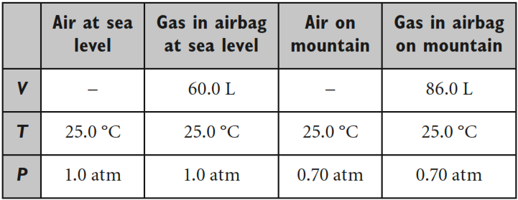

1. Consider the gas trapped inside the air bag. How do the volume, pressure, and temperature of the gas change as you go from sea level to the mountaintop?

2. Why is the volume of the air bag different in the two locations?

3. A different car has an air bag that inflates to 60 L on the mountaintop, where the air pressure is 0.70 atm and the temperature is 25 °C. What volume will this air bag have at sea level? Show your work.
Initial Final
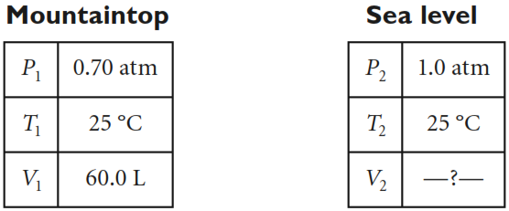

4. Compare a rigid container, such as a glass bottle, with a flexible container, such as an air bag. Describe how the type of container affects how the pressure of the gas inside the container can vary.

3. Fill in the table. The first line of the table gives the volume, pressure, and temperature for a container of gas. The gas starts in a container with a volume of 22.4L. The pressure is 1.0 atm and the temperature is 300K. Each subsequent row represents a new set of conditions for this gas. Fill in the blank spaces.
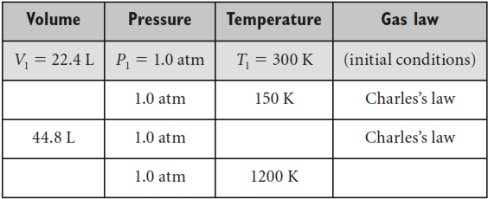
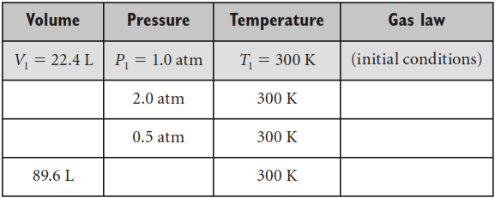
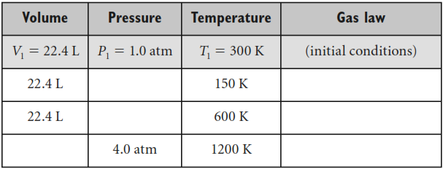
a) When the temperature is constant and the volume decreases, what happens to the pressure? Provide an example of when this might occur.

b) When the pressure is constant and the temperature decreases, what happens to the volume? Provide an example of when this might occur.

c) When the volume is constant and the pressure increases, what happens to the temperature? Provide an example of when this might occur.

Making Sense Questions:
Describe how the type of container affects how the pressure of the gas inside the container can vary.

