Sorry, Charlie
(Adapted from Living By Chemistry Preliminary Ed “Absolute Zero” and 1st Ed “Sorry, Charlie”)

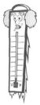
Purpose: This lesson allows you to examine the relationship between volume and temperature in gases and introduces you to the Kelvin scale.

Part I: A quantity of gas was heated to various temperatures. Each time the temperature changed, the volume of the gas was measured in milliliters. The temperature was sometimes measured in degrees Celsius and sometimes in Kelvin. Note that V represents volume and T represents temperature.

Fill in the remainder of the table:
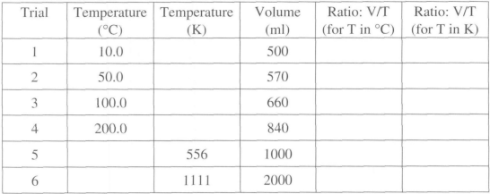
1. What do you notice about the ratio of volume to temperature for the different trials?

2. When the temperature was doubled in degrees Celsius, did the volume also double?
3. When the temperature was doubled in Kelvin, did the volume also double?
4. Whenever the volume doubled, did the temperature also double? What appears to be the difference between using the Kelvin scale and the Celsius scale in this situation?

Part II:
1. A Happy Birthday balloon is filled with three breaths of air. It has an initial volume, V₁, of 400 mL at the initial temperature, T, of 285 K. The air in the balloon is cooled to 265 K and the volume decreases. Next, the air in the balloon is heated to 300 K and the volume increases. Calculate the missing values for the birthday balloon.
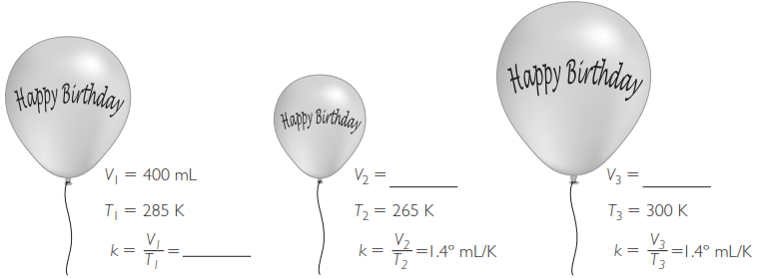
2. A New Year’s balloon is inflated with five breaths of air. It has an initial volume of 600 mL at 285 K. It is heated to a temperature that changes the volume of air in the balloon to 630 mL. Next the air in the balloon is cooled to 265 K. Calculate the missing values for the New Year’s balloon.
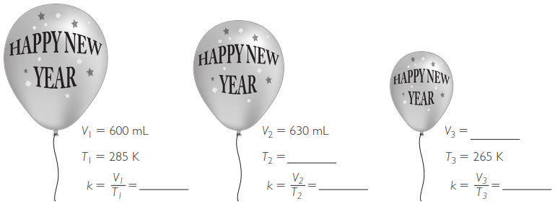

3. Plot volume versus temperature in Kelvins for the Happy Birthday balloon and the New Year’s balloon on the graph. Label each line.
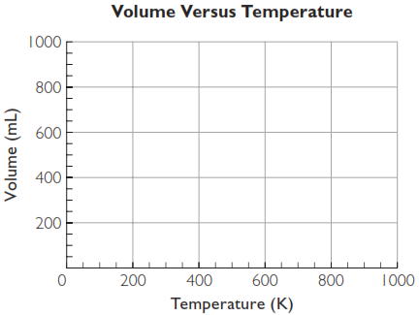
4. Use the graph to find the approximate volume of the Happy Birthday balloon and the New Year’s balloon at a temperature of 400 K.

5. Why do you suppose the Happy Birthday balloon has a different proportionality constant, k, than the New Year’s balloon?

6. What is the volume of both gases at 0 K?

Part III: Problem Solving
(Remember to always convert temperatures to the Kelvin scale.)
1. The beginning volume of a gas is 500 mL at 20 °C. The temperature is raised to 35 °C. What is the new volume of the gas?

2. Suppose you have a Valentine’s Day balloon with a volume of 300 mL at 300 K.
a. Is the proportionality constant larger or smaller than that for the birthday balloon?

b. At the same temperature, which balloon is smaller, the Valentine’s Day balloon or the New Year’s balloon?

Part IV: Imagine that you are getting ready to go up in one of these hot air balloons. Around noon you fill a balloon to a volume of 50,000 L at 100.0°C. Late the day becomes cloudy and chilly, and the temperature inside the balloon drops to 50.0°C.
1. Do you predict that the balloon will get bigger or smaller? Explain your reasoning.

2. What is the ratio V/T at the beginning of the day? (Be sure to use Kelvin).
3. What is the ratio V/T when the temperature drops to 50.0°C?

Making Sense:
What is the volume of the balloon described in Part III when the temperature is 50°C? (Be sure to use Kelvin)

