Stoichiometry Resources
Equations:

grams grams
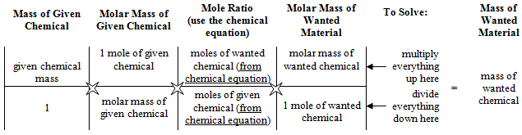
D₂UM₂ moles grams
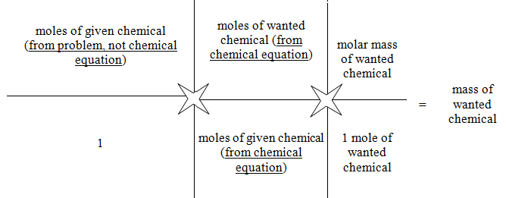
Divide given by molar mass
Divide by given coefficient
Move Under wanted
Multiply by wanted coefficient
Multiply by wanted molar mass

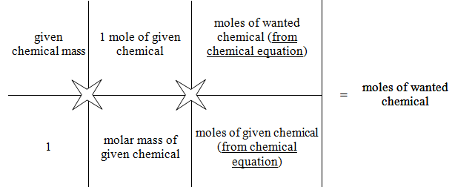
moles moles grams moles
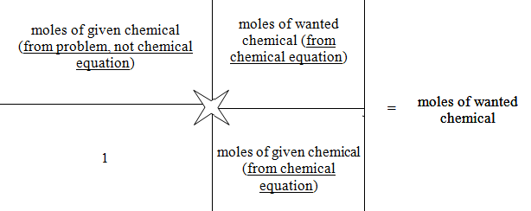
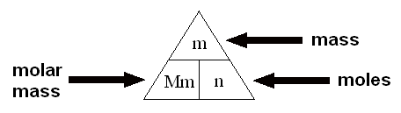  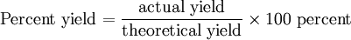 | # of particles = moles × 6.02 × 10²³  __# of particles__ = moles  6.02 × 10²³

Online Resources:
Mr. Guch’s Cavalcade O’ Chemistry – Explanations and worksheets
http://misterguch.brinkster.net/molecalculations.html
http://misterguch.brinkster.net/stoichiometryexplained.pdf
http://misterguch.brinkster.net/pra_equationworksheets.html

ChemTeam – has videos and lots of examples and practice problems
http://www.chemteam.info/Mole/Mole.html
http://www.chemteam.info/Stoichiometry/Stoichiometry.html

