Where’s the Heat?
Heat and Phase Changes

Purpose
To examine the temperature of water as it undergoes phase changes.

Materials
100 mL beaker Plain Ice Ice with Salt
Time | Temperature | Phase
1 min
2 min
3 min
4 min
5 min
6 min
7 min
8 min
9 min
10 min
11 min
12 min
13 min
14 min
15 min
16 min
17 min
18 min
19 min
20 min
Time | Temperature | Phase
1 min
2 min
3 min
4 min
5 min
6 min
7 min
8 min
9 min
10 min
11 min
12 min
13 min
14 min
15 min
16 min
17 min
18 min
19 min
20 min
50 mL of crushed ice
Thermometer
Hot Plate

Part 1: Melting Ice

Procedure and Questions

1. Place about 100 mL of crushed ice in a 100 mL beaker.

2. Use your thermometer to record the initial temperature (IN CELSIUS!) of the ice. Try not to let the thermometer touch the glass, otherwise you will end up measure the temperature of the glass rather than the ice/water.

3. Every minute, measure the temperature (IN CELSIUS!). On the data table, record the time, the temperature, and the phase or phases present in the beaker (phases include: solid, both solid and liquid, liquid, both liquid and gas).

4. Perform the procedure again, but this time, add a small amount of salt (5 g) to your ice.

4. Graph the data according to the instructions on the back page.

Processing the Data
1. Make a graph that plots the temperature over time.
2. On the graph, label the areas where the following phase or phases are present: solid, both solid and liquid, liquid, both liquid and gas

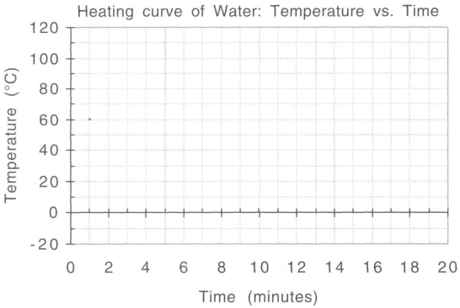

1. Describe your graphs. How do the temperature of plain ice and ice with salt change over time?

2. Write a conclusion about what salt may do to ice.

3. The freezing point of water is 0°C and the boiling point is 100°C. What does the freezing point and boiling point of a substance tell you?

4. Would you say the freezing point is the same when you add salt?

Making Sense
What do you think it means when the graph isn’t a straight line?

