Gibbs Free Energy Practice Problems

1. Using the following values for ΔH, ΔS, and T, determine the change in free energy and if the reaction is spontaneous or nonspontaneous.
a) ΔH = 40,000 J, ΔS = 300 J/K, T = 130 K
b) ΔH = 40,000 J, ΔS = 300 J/K, T = 150 K
c) ΔH = 40,000 J, ΔS = -300 J/K, T = 150 K

2. Given the following information, calculate ∆G° for the reaction below at 25.0°C:

SnCl₄(l) + 2 H₂O(l) → SnO₂(s) + 4 HCl(g)

∆H° = 133,000 J and ∆S° = 401.5 J/K

3. Calculate ΔG° for the reaction below. The standard molar entropy change for the reaction at 298 K is -287.5 J/K.
3NO₂(g) + H₂O(l) 2HNO₃(aq) + NO(g) + 136,800 J

4. What is the standard free energy change, ∆G, for the following reaction at 25°C? The ∆H = -91,800 J and ΔS =
-197 J/K.

N₂ (g ) + 3H₂ (g ) → 2NH₃ (g )

5. Answer the questions below for each of the following reaction coordinate diagrams:

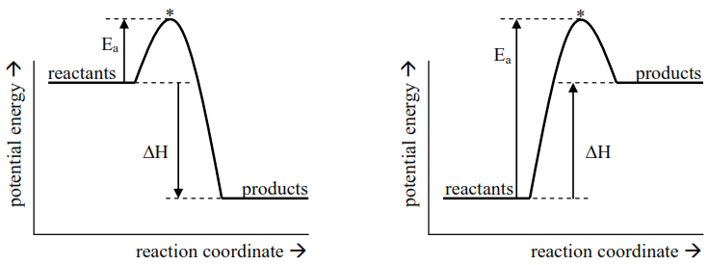
a) Is the reaction exothermic or endothermic? a) Is the reaction exothermic or endothermic?

b) What is the sign of ΔH? b) What is the sign of ΔH?

c) Is heat absorbed or released? c) Is heat absorbed or released?

d) What happens to the temperature of the d) What happens to the temperature of the
surroundings? surroundings?

6. Find the ∆G for the following reaction at 25.0°C and 1000.°C. The ∆H = -178,300 J and ΔS = -159 J/K. Relate this to reaction spontaneity.
CaCO₃ (s) → CaO (s) + CO₂ (g)
7. The combustion of acetylene is as follows:
C₂H₂(g) + 5/2 O₂(g) --> 2 CO₂(g) + H₂O(g)

Calculate the ∆G given that the ∆H = -1238 kJ and ∆S = -97.4 J/K or -0.0974 kJ/K at a temperature of 298K.

8. Calculating ∆G of a reaction where ∆H = +25.7 kJ and ∆S = +108.7 J/K or +0.1087 kJ/K at a temperature of 25°C.

9. For the reaction below:
2 Fe₂O₃(s) + 3 C(s) ---> 4 Fe(s) + 3 CO₂(g)

The ∆H = +467.9 kJ and ∆S = +560.3 J/K or +0.5603 kJ/K. Is this reaction spontaneous at 298k?

10. Based on the following equation:

2 C₃H₇OH (l) + 9 O₂ (g) 6 CO₂ (g) + 8 H₂O (g) + heat

a) Is this reaction exothermic or endothermic? (circle one)
b) Is the entropy (randomness) of the system increasing or decreasing? (circle one)
c) Label the sign (+ or –) of each variable in the equation below. If ΔG depends on the temperature, enter a question mark (?).
ΔG = ΔH – T ΔS
( ) = ( ) – ( )( )
d) At what temperatures is the reaction above spontaneous? (circle one below)

at all temperatures only spontaneous at only spontaneous at at no temperatures
(always spontaneous) low temperatures high temperatures (never spontaneous)

11. Based on the following equation:

NH₄Cl (s) + heat NH₄ + (aq) + Cl– (aq)

a) Is this reaction exothermic or endothermic? (circle one)
b) Is the entropy (randomness) of the system increasing or decreasing? (circle one)
c) Label the sign (+ or –) of each variable in the equation below. If ΔG depends on the temperature, enter a question mark (?).
ΔG = ΔH – T ΔS
( ) = ( ) – ( )( )
d) At what temperatures is the reaction above spontaneous? (circle one below)

at all temperatures only spontaneous at only spontaneous at at no temperatures
(always spontaneous) low temperatures high temperatures (never spontaneous)

Partial Answers (in random order):
-131000 -51100 -33000 -5000 -1210 -6.7 301 1000 13400 24100 85000
J J J J J J J J kJ kJ kJ

