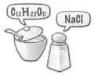
A New Language
Chemical Names and Symbols

Purpose
To learn the language of chemical symbols and chemical names.

Part 1: Observations
Look at each vial and fill in the data in the table.
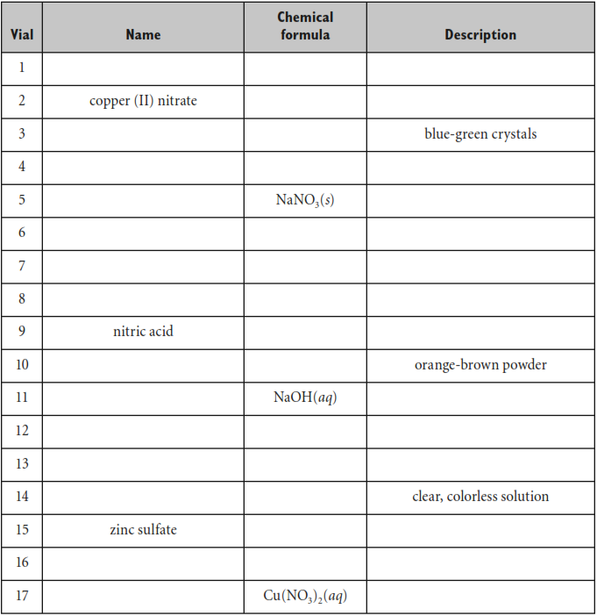
Part 2: Cracking the Code
1. Examine the contents of the vials and their labels. Write down at least six patterns you notice.

2. These symbols represent elements. Identify each element.
a. Cu b. H c. Zn

3. Translate these element names into their symbols.
a. sulfate b. nitrate c. hydroxide

4. Compounds are substances that are made up of more than one element. In your data table, place a C next to the number of each vial that contains a compound.

5. What do you think (s), (l), and (g) stand for?

6. How would you write the chemical formula for ice?

7. What do all the substances labeled (aq) have in common?

